Data Modelling

In this section we compared the performance of 4 models with each other with and without holdout approach. The train and test sets were divided using Hold-Out approach in a 80:20 ratio using the following models:

* Decision Tree

Hyper Parameters= criterion='gini', splitter='best'

* Random Forest
* Neural Networks

Hyper Parameters= hidden_layer_sizes=(150,100,50), max_iter=300,activation = 'relu',solver='adam',random_state=1

* Logistic Regression

Hyper Parameters= solver='liblinear', random_state=0

Confusion Matrix and Accuracies with IRUS:

Decision tree Random forest

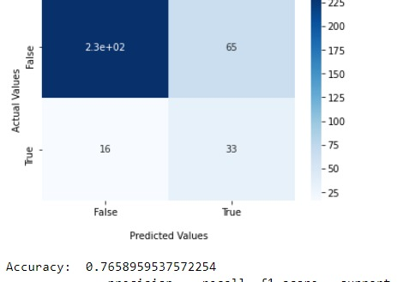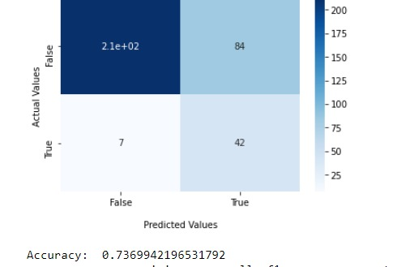

Neural Networks

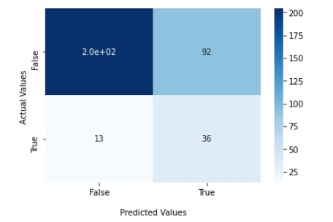

Logistic Regression

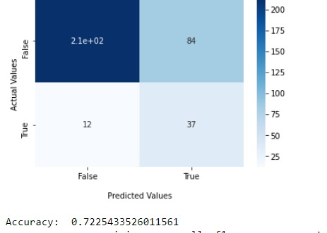

Confusion Matrix and Accuracies without IRUS:

Decision tree

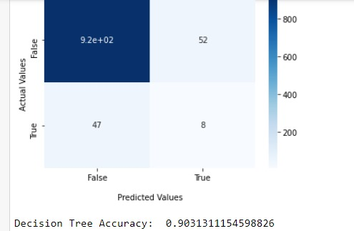

Random forest

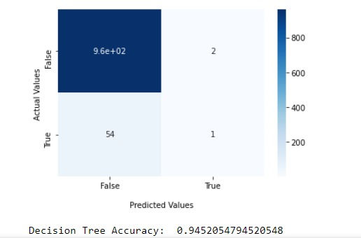

Neural Network

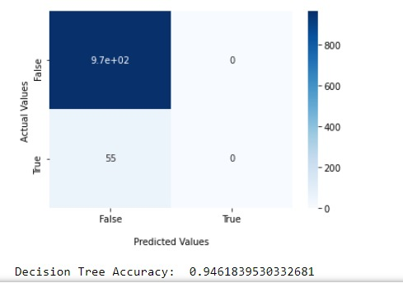

Logistic regression

